WSH

Using our know-how for complex reaming applications

WSH-TOOLS deals with the processing of precision components in various sectors. The automotive- Aerospatiale -industrial sector applications focus on one core area where some highly complex reaming / Drilling/ clamping / PCBN applications are required. In addition to a wide standard range of reamers, customers benefit from the know-how of WSH-TOOLS, experts in designing and producing special tools. The result is reaming tools with the tightest tolerance requirements that can be met.

WSH-TOOLS has extensive expertise in the development and production of high-precision tool solutions. Within WSH-TOOLS, Wsh-Tools Belin is the competence center for reaming tools and, in association with WSH-TOOLS Kieninger, offers an extensive range of reaming and drilling tools: from solid carbide reamers, through complex line boring bars, to highly developed special tools.

---Reamers – standard – specials

◼ Solid carbide reamers

◼ Reamers with soldered cutting edges (carbide, PCD, CBN and Cermet)

◼ Expandable reamers

◼ Modular reamers

◼ Single and twin-blade reamers

◼ Fine turning inserts

◼ ISO cartridges

◼ Customized reaming tools for specific application

---HOLDERS / CLAMPING --

The product range is supplemented by a wide range of clamping systems to optimize the reaming process:

* Hybrid
* Adjustable clamping systems
* Floating tool holders

To achieve the highest quality during bore fine machining, the respective reamers must be set exactly to the required tolerance.

Compensation Holder Product Features:

* Compensation holder for HSK, SK, CAT, MAS / BT
* With internal coolant supply
* For tools with Weldon flat, Cyl. shunk and flange Module Product Advantages:
* Correction of runout errors and misalignment
* Easy to set
* Maximum process safety due to correction of runout
* Extended tool life due to correction of runout
* Highest quality of bores due to correction of runout

Drills

Drills with high performance, standard and special dimension according customer requirements

PMK for al type of steel

M for stainless steel

N for aluminum alloys

Para acero integral

Para acero templado y superaleaciones

Para Aluminio

Para libre de Oxido

PCBN inserts

PCBN inserts in the standard configuration according to our catalog and special PCBN insert according to customer requirements.

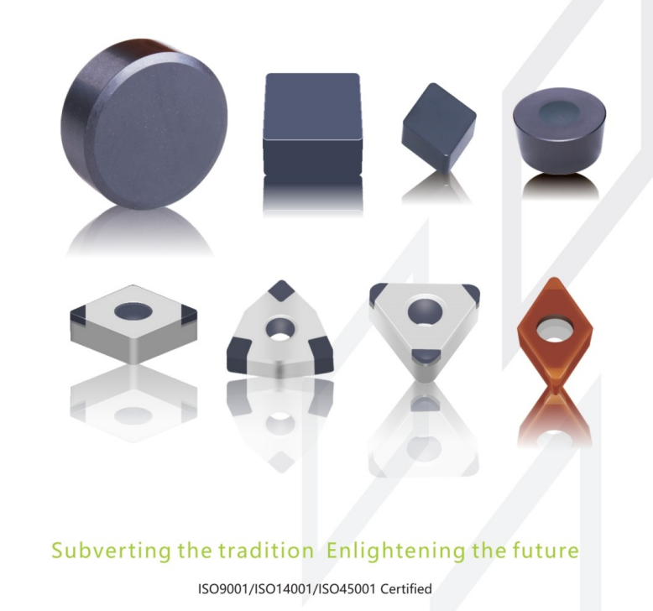

Pasar a texto

* Impact resistance solid- insert
* Brazed solid-TIP -insert
* Single-layer brazed coated insert
* Single-layer brazed insert with high cost performance
* Multi-layer composite nano-coating for PCBN

GUN DRILLS

In the machining world, drilling depths of 10 x D and deeper are regarded as deep hole drilling operations, whereby smaller drilling depths can naturally also be produced with gun drills. The advantage is taken of the positive side effects, as for example good surface quality, low deviation from concentricity and optimised alignment accuracy.

Single-fluted gun drills E 100

Single-fluted gun drills E 80

Gun drills with 2 cutting lips Z 80

Single-fluted gun drills with interchangeable inserts E 800

Inserts for single-fluted gun drills E 800



Supporting strips for single-fluted gun drills E 800



BAND SAW

SHELL END MILLS WSH 90

COUNTERSINK

* Form C
* Cross hole

with straight shank, bright finish, TIN or TIALN coated, 3-Cutter Range of applications For core and deburring in nonmetals and for all common steel sheets. Higher surface hardness by coating.

MACHINE TAPS

Machine taps

Form B

From C

With reinforced shank, steam treated, ISO 2 / 6H Range of applications

For through holes and for machining steels generally, high-strength steels, rust and acid-resistant steels, aluminum and aluminum alloys, owls cast materials.

Hacer referencia a la pagina de WSH

: [wsh-tools.de](http://wsh-tools.de)